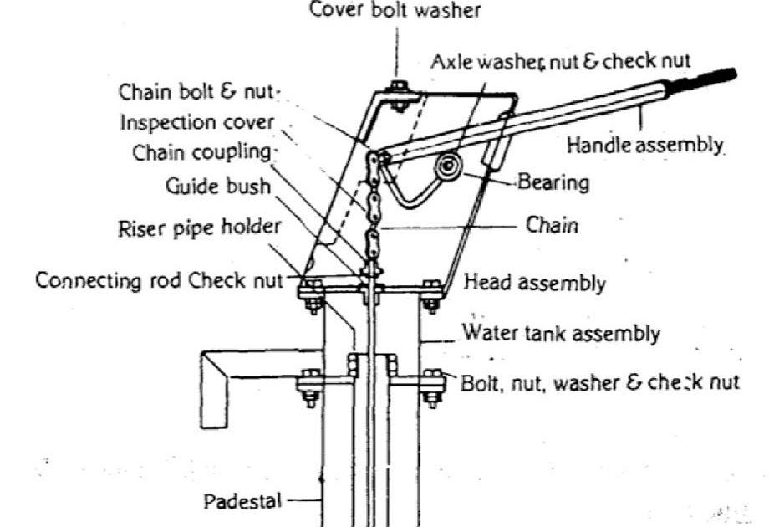

2. The depth 100m per site.

3. Construct a minor drainage system to keep the area free from stagnant water.